ARGO CD TASKS
- SETUP ARGO CD
Login into your k8s cluster and install ArgoCD
• kubectl create namespace argocd
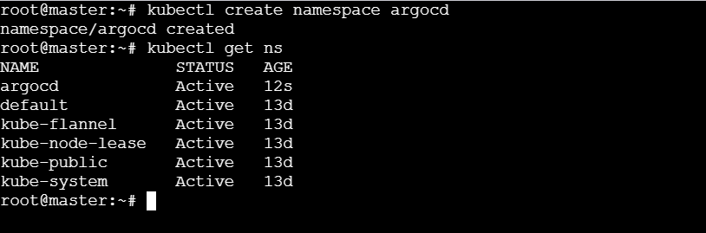
- kubectl apply -n argocd -f https://raw.githubusercontent.com/argoproj/argo-cd/stable/manifests/install.yaml
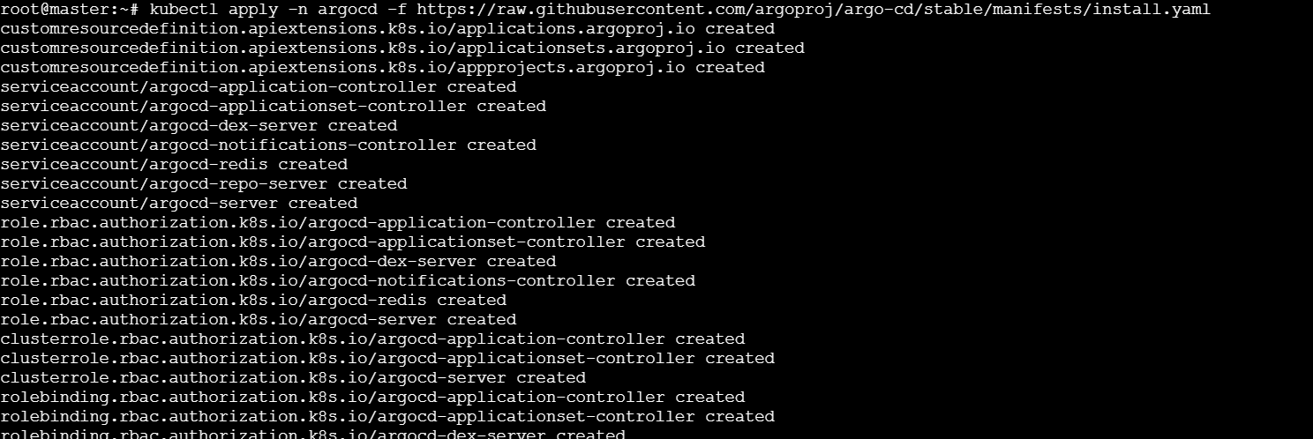
# kubectl get pods -n argocd
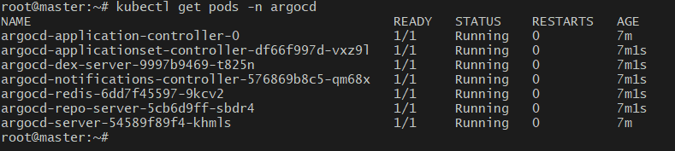

# kubectl get svc -n argocd
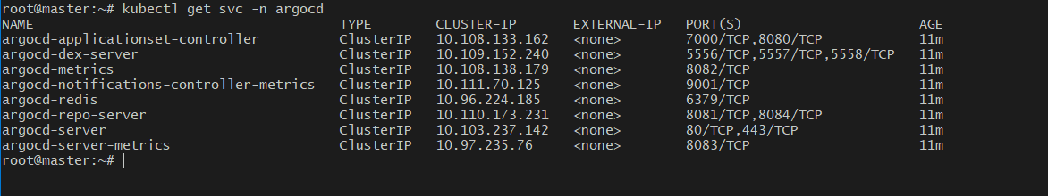
# kubectl patch svc argocd-server -n argocd \
-p '{"spec": {"type": "NodePort"}}'
# kubectl get svc argocd-server -n argocd
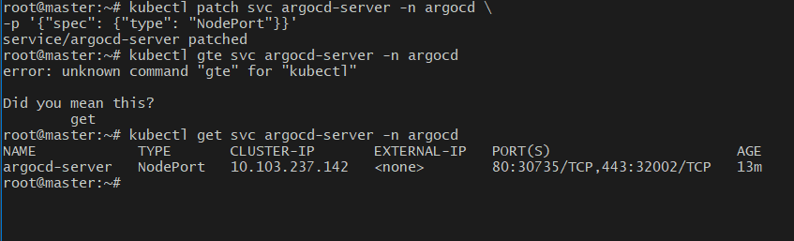
- acess this on port no 30735
# kubectl get secret argocd-initial-admin-secret -n argocd \
-o jsonpath="{.data.password}" | base64 -d
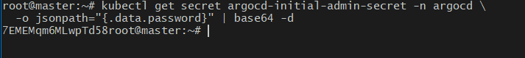
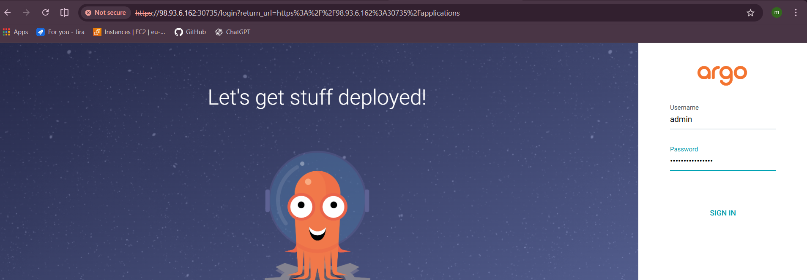
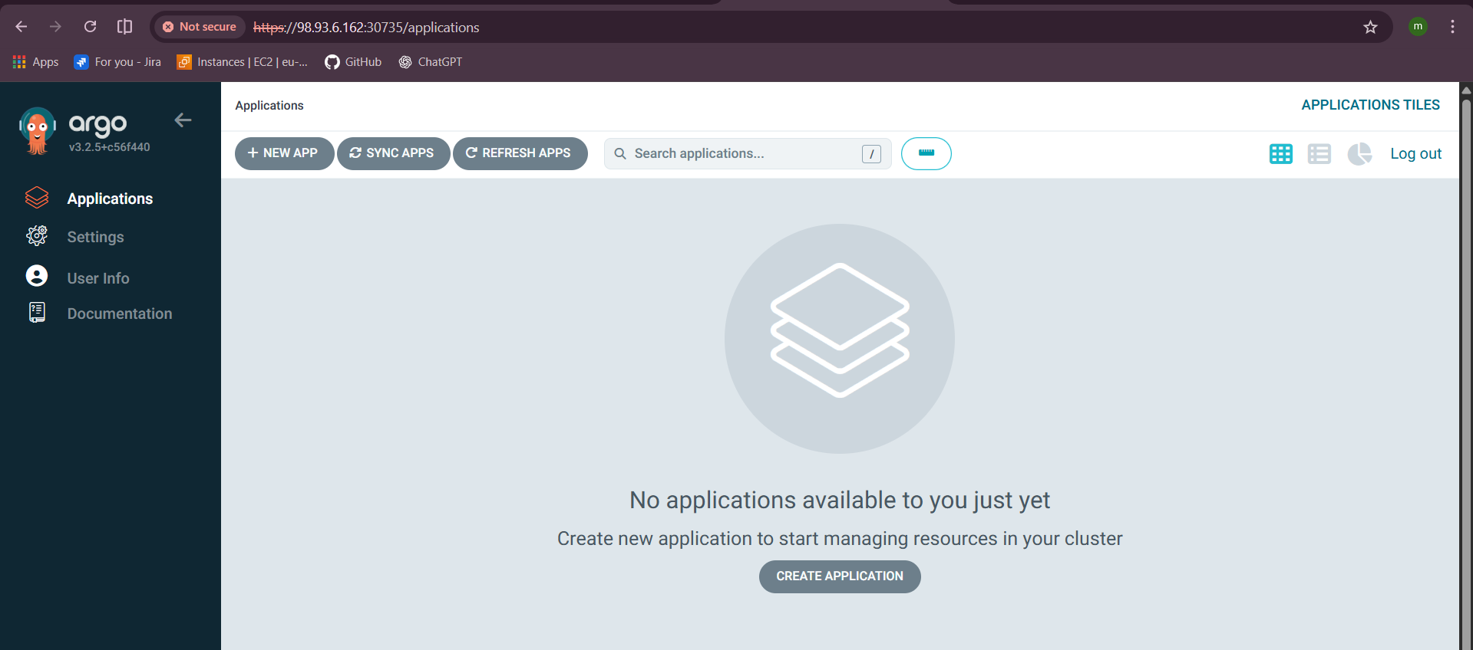

- Create Jenkins job for CI.
Login into Jenkins server and build a new job with the name ci-job and select type as pipeline.
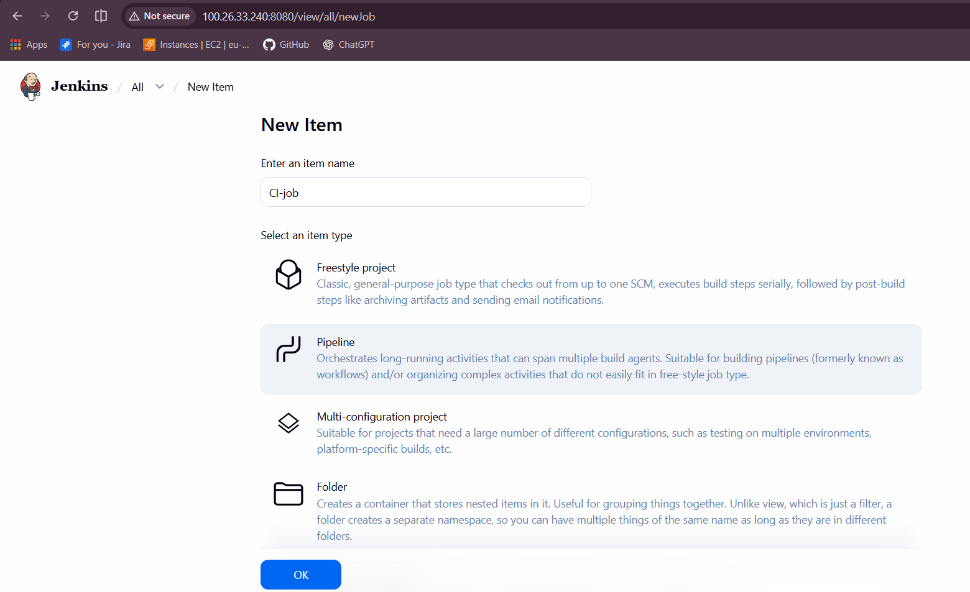
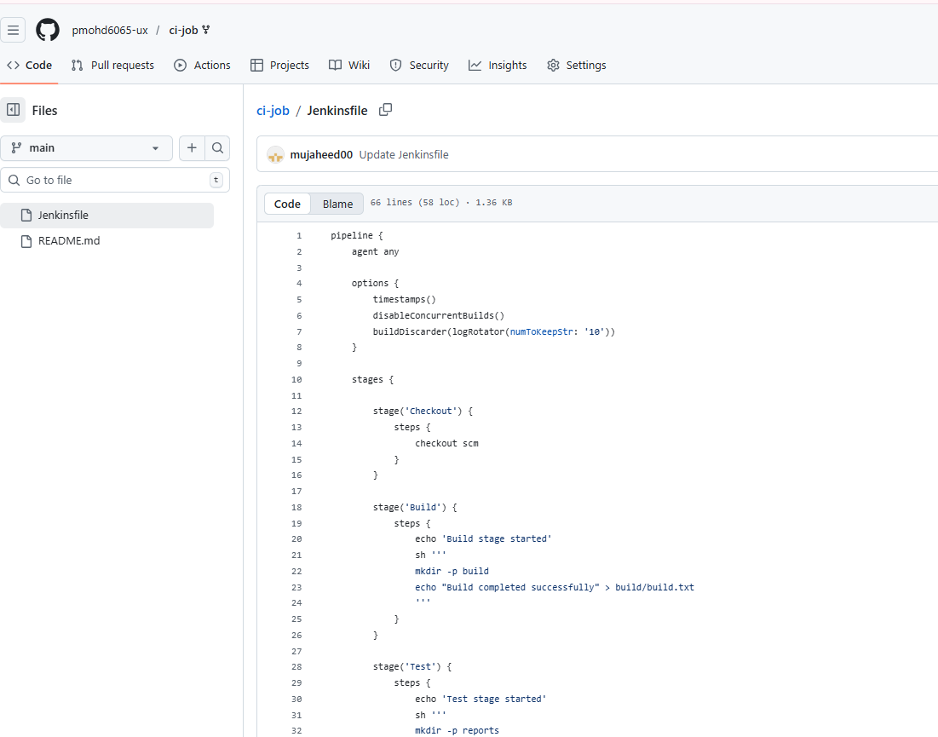
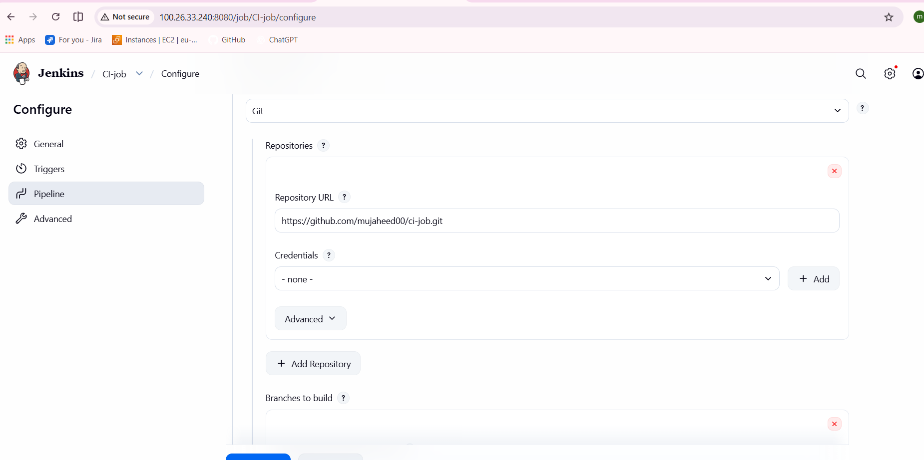
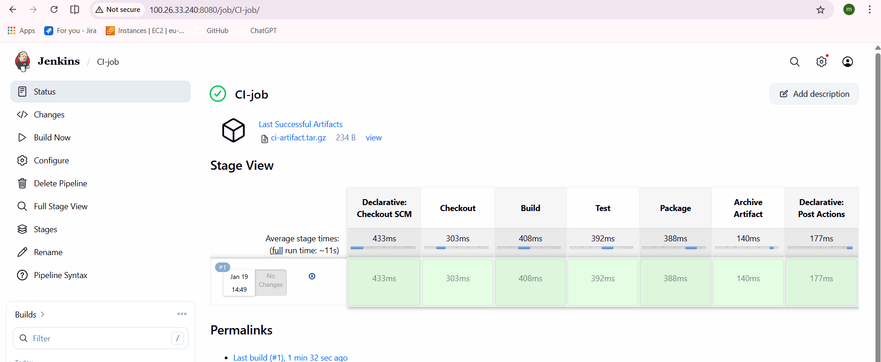

- Create Jenkins job to create docker image and build image.

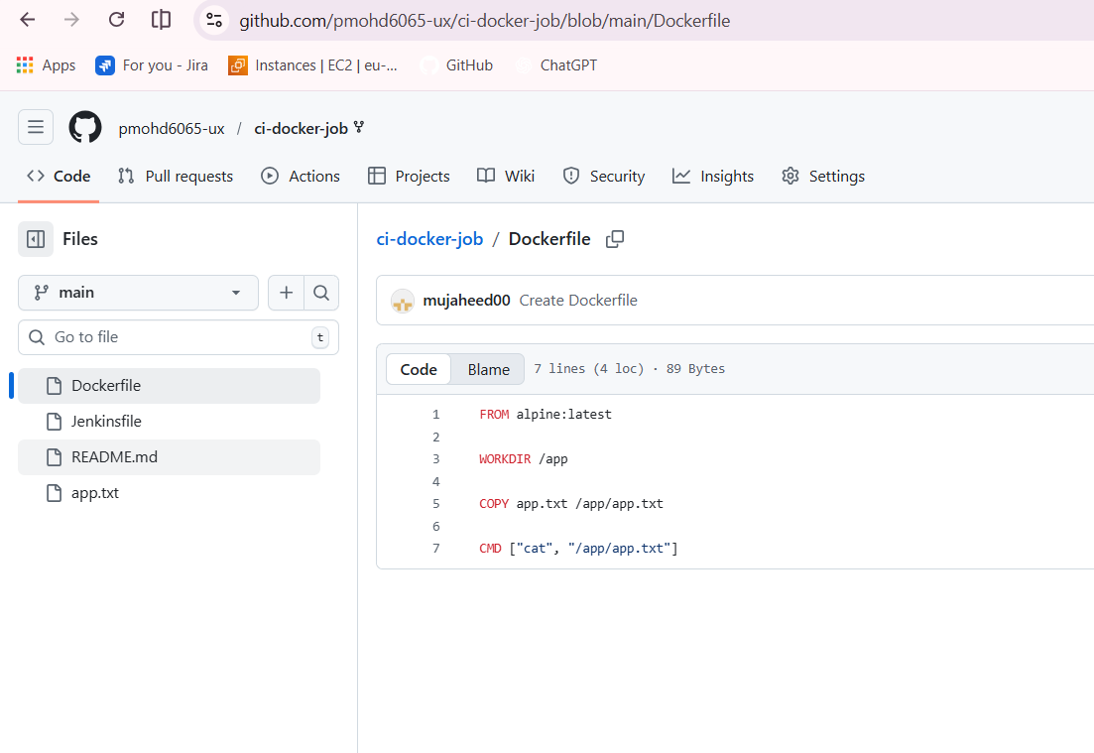
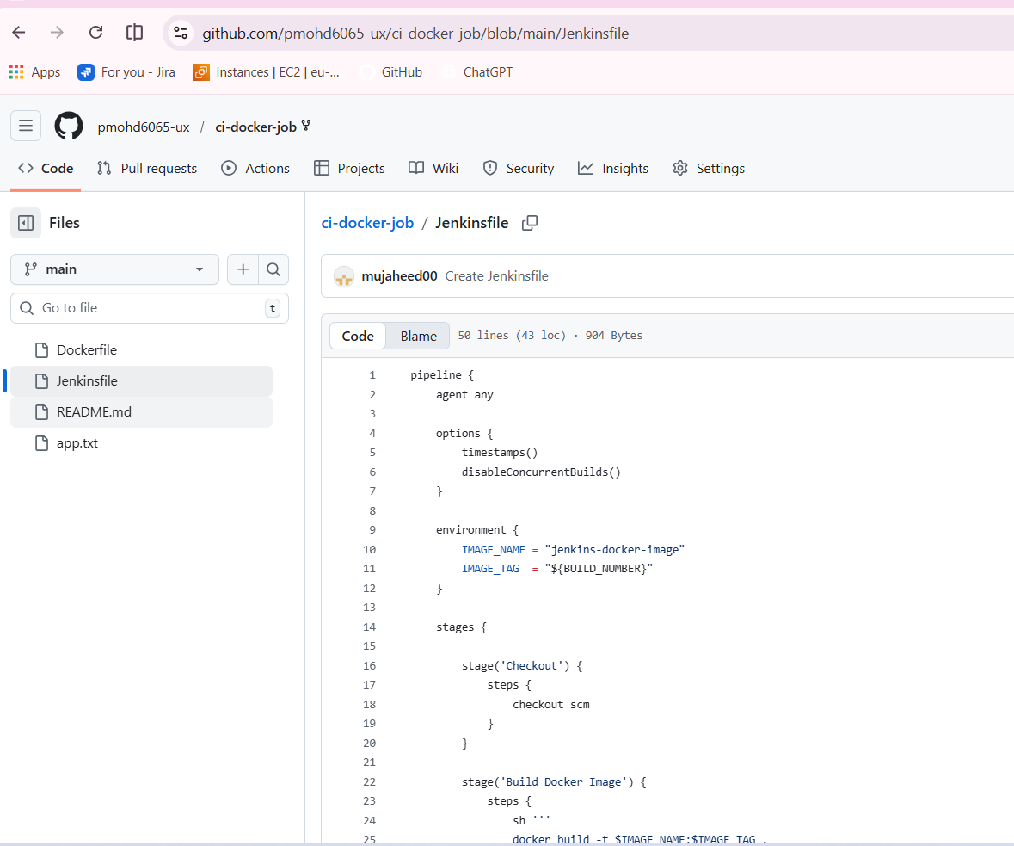
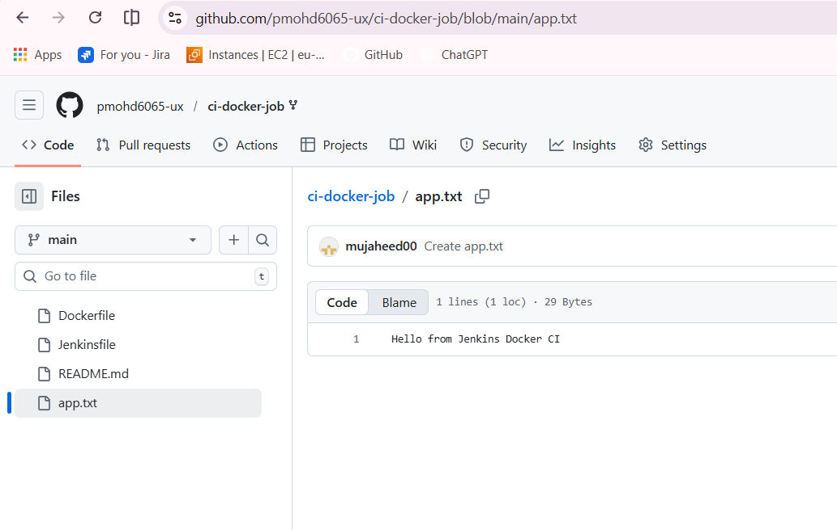
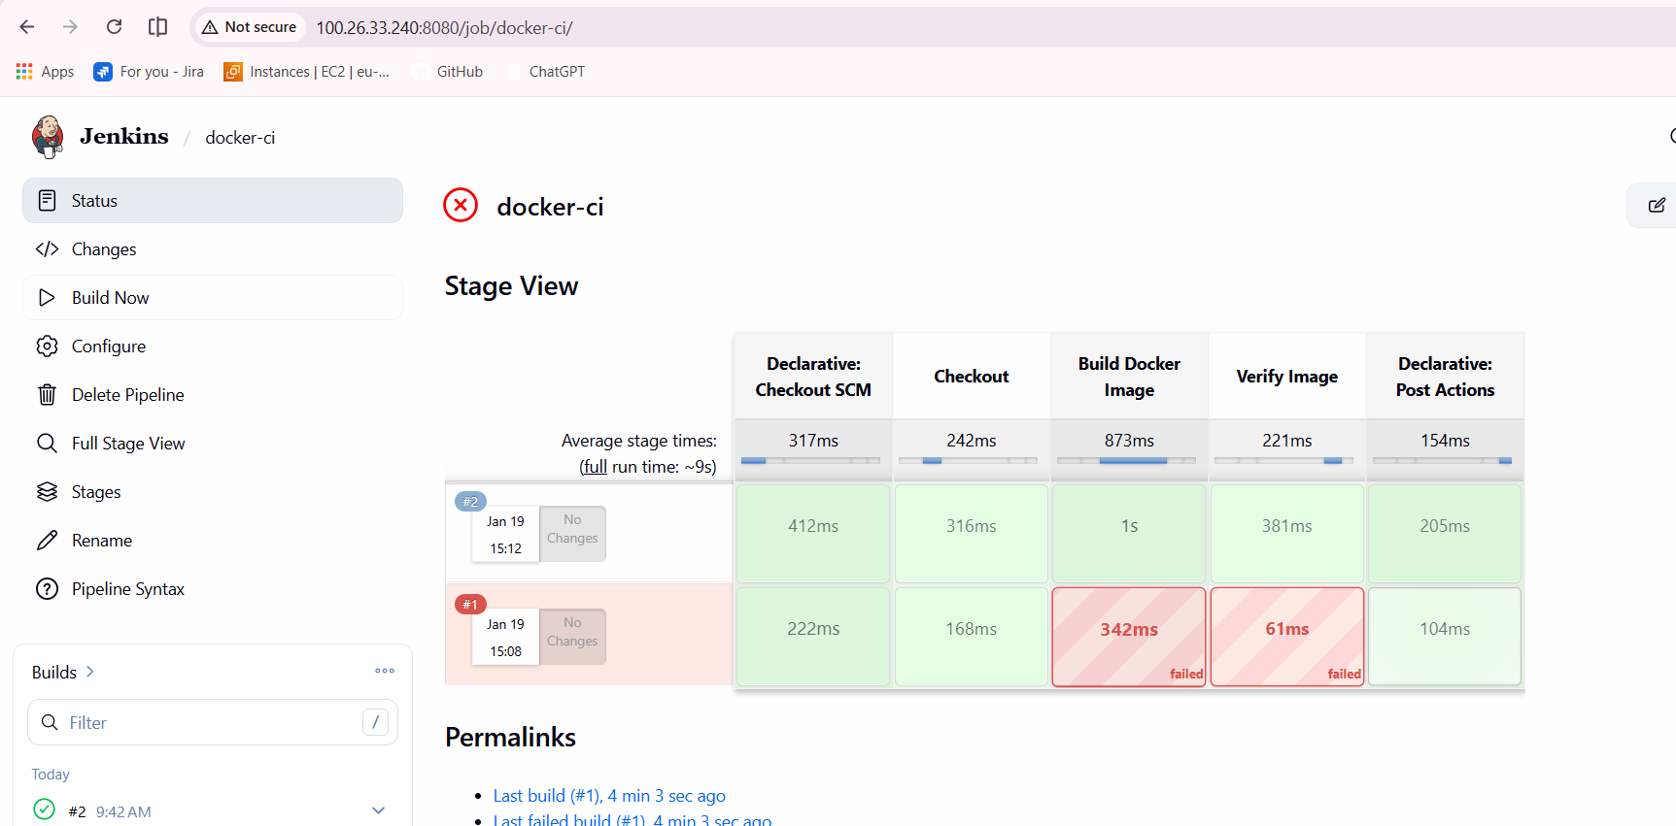

- Create ArgoCD job to deploy on ek8s cluster.
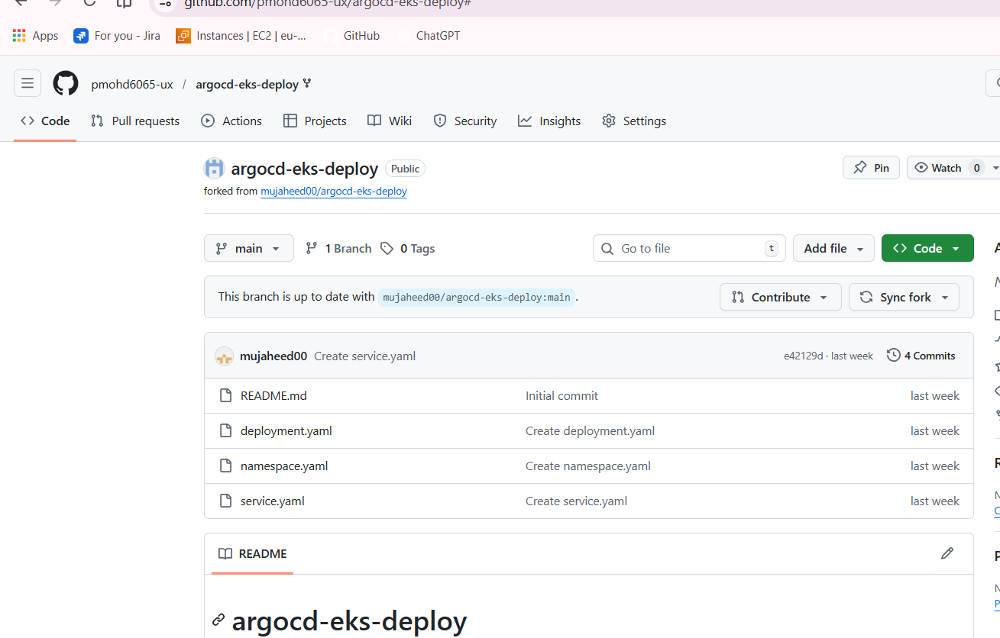
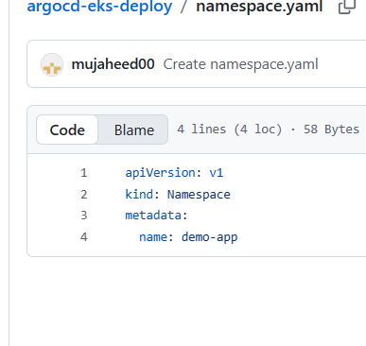
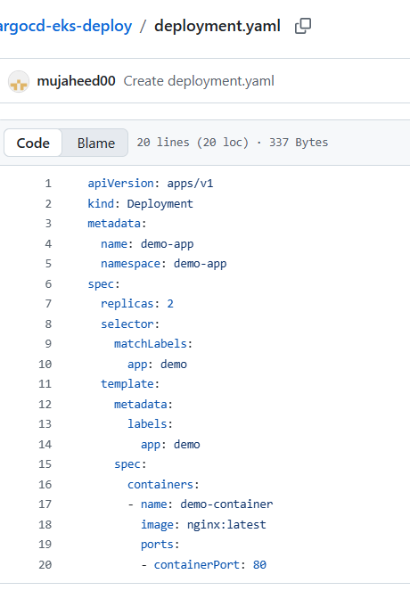
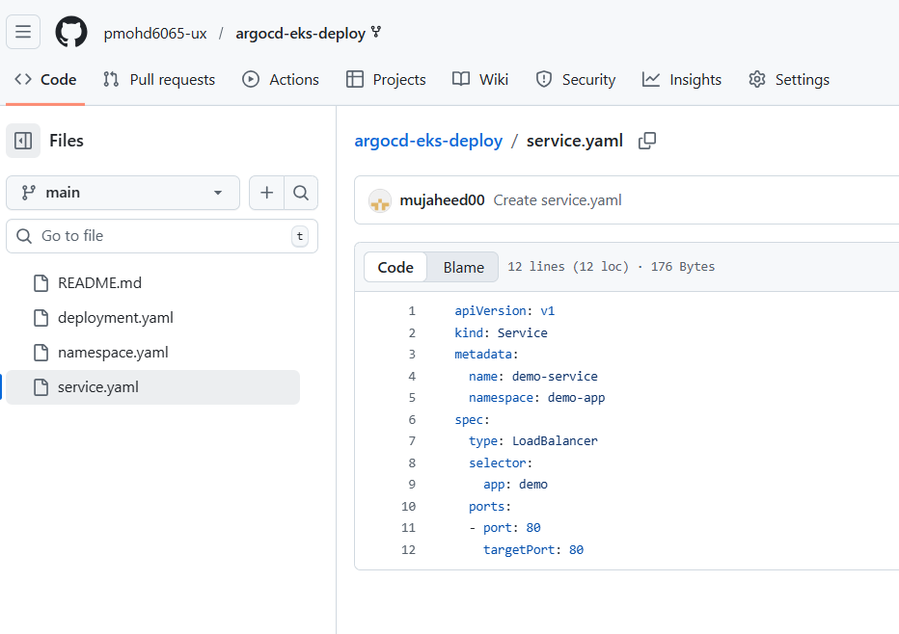
Go to argocd GUI and click on new app
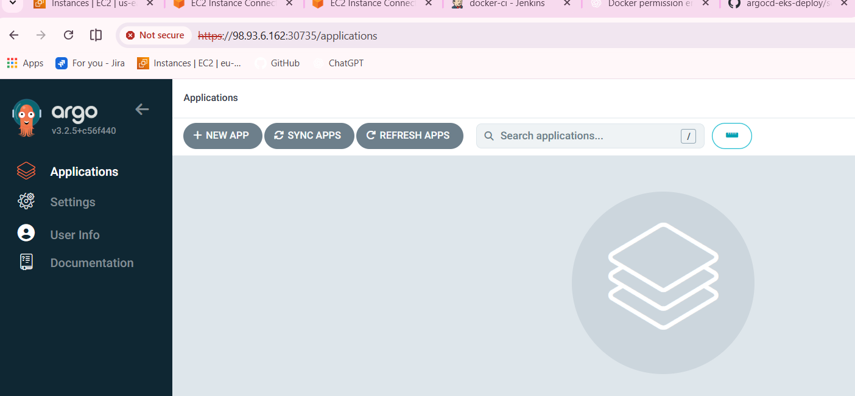
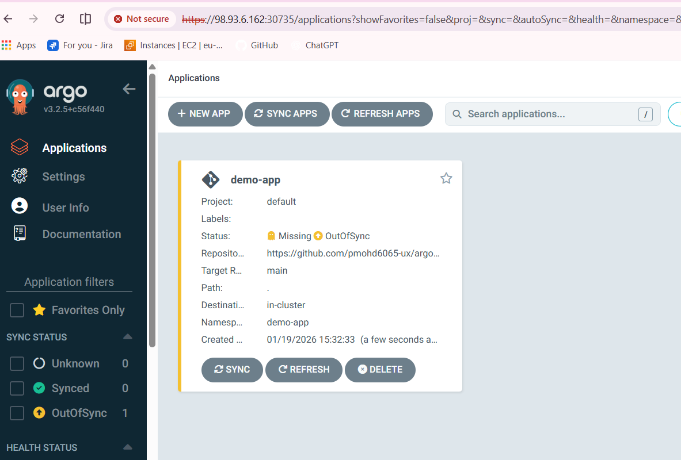
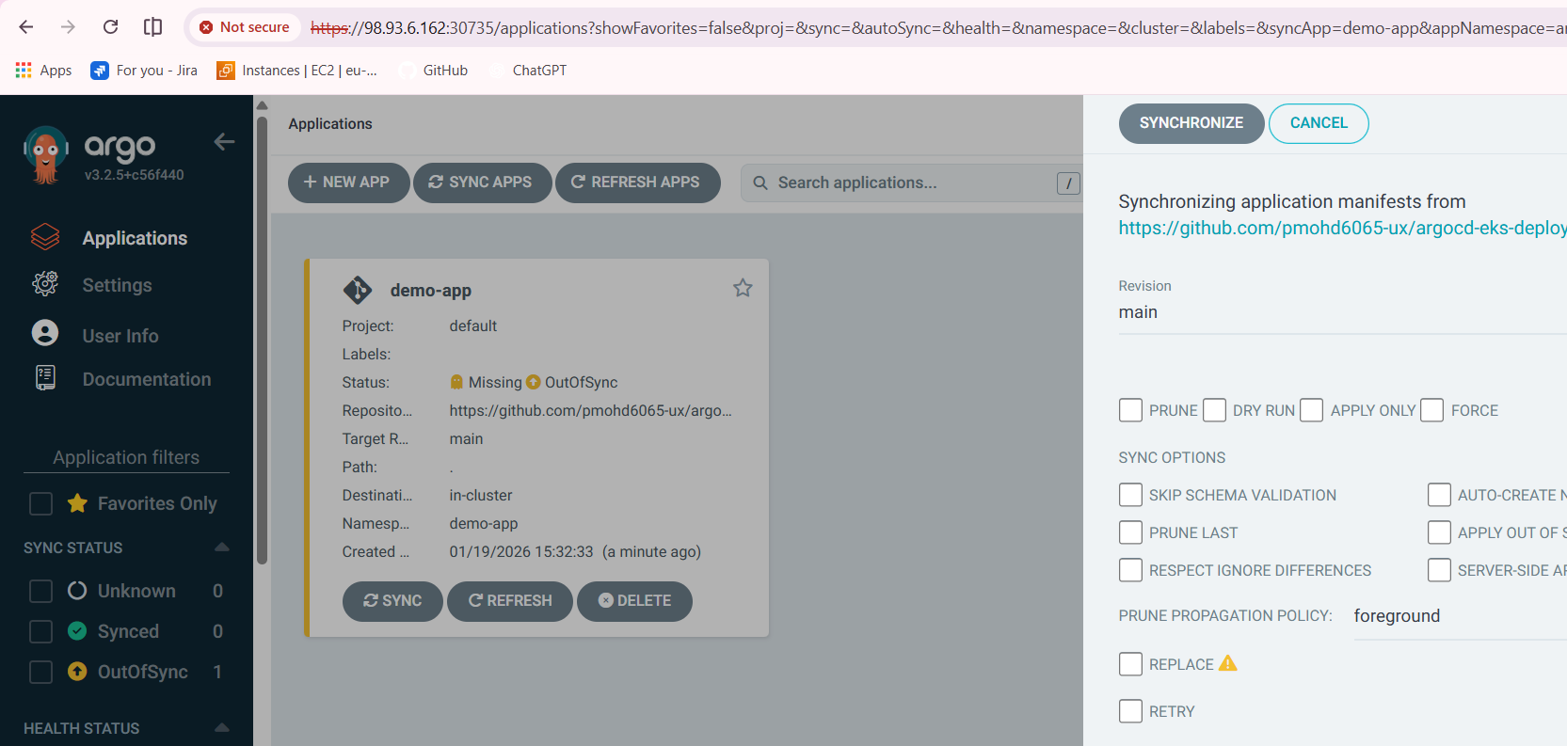
# kubectl get svc -n demo-app
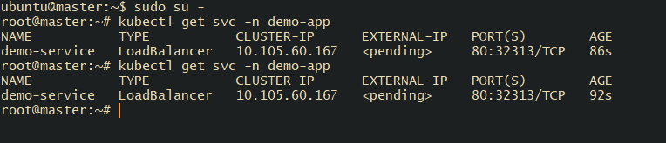
Access in your browser with your ip and port 32313
